

# Big Purple Phone

## Type of device: Mobile

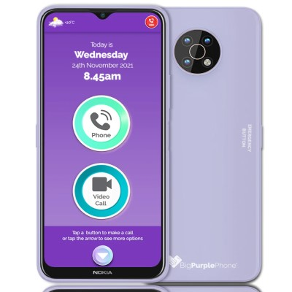

Button Type : Touchscreen

Operating System : Android

Version Number : Android 11

Network Capability : 3G,4G,5G

## Accessibility Features:

### Cognitive

* Additional Instructions
* Photo Telephone List
* Simple Instructions
* Simple Reminders

Simplify Display

### Hearing Impairment and Deaf

* Closed Captioning
* Front Facing Camera
* Text Messaging/SMS
* Vibrating Alerts - Adjustable
* Video Communications - Two-way

Visual Alerts - Incoming Calls

### Vision

* Battery Alert - Audible
* Key Numbers - Standard Layout

Key Press - Vibration or Click

### Speech

Messaging Options - IM

### Physical

* Headset - plug connected
* Speaker-phone option

Stylus or Prosthetic Device support

## How and where to get it from?

You can buy this phone from [BigPurplePhone](https://bigpurplephone.com.au/)

## More information is available on:

[BigPurplePhone Options](https://bigpurplephone.com.au/collections/choose-your-bigpurplephone)

[BigPurplePhone Features](https://bigpurplephone.com.au/pages/features)

[BigPurplePhone Contact](%60)